## 1.Add Migration

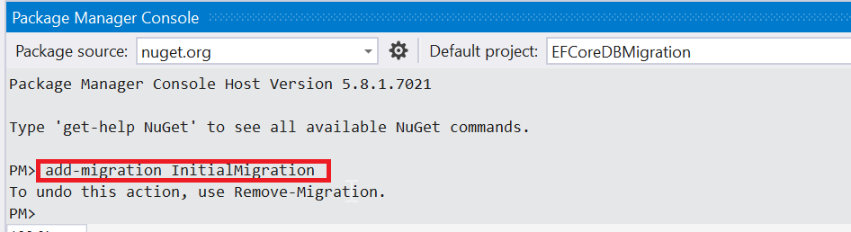

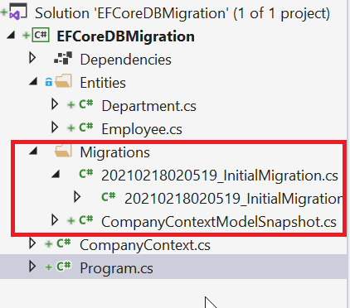

## 2. Update Database

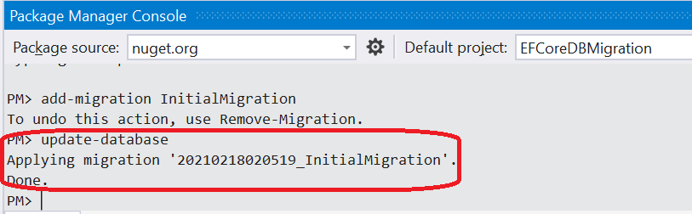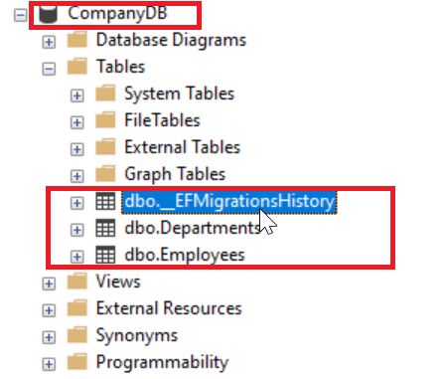

## 3. Add new migration to add new column to Table

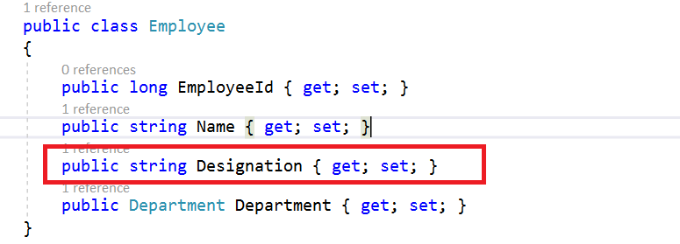

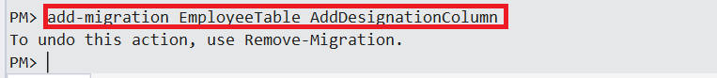

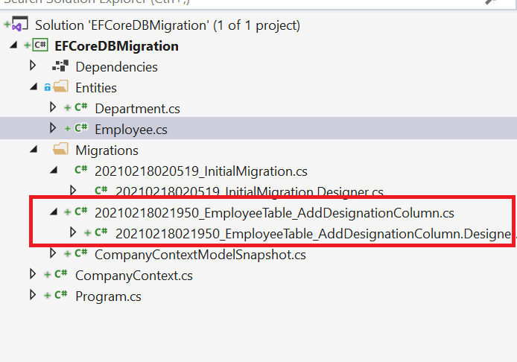

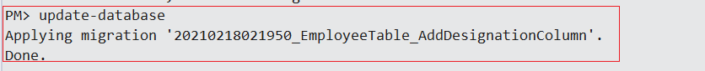

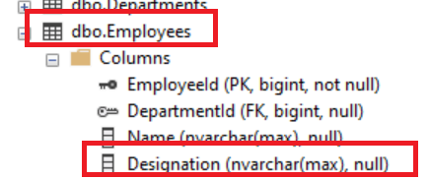

## 4. Revert Migration (If you want to revert the database to previous state)

Use update database command with previous migration to revert the database state.

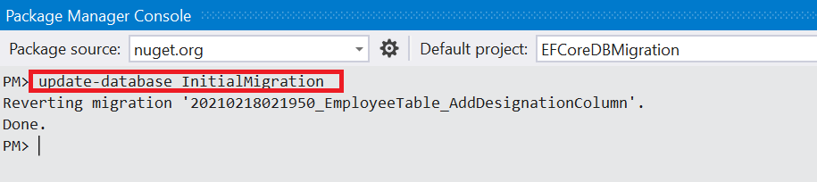

This will remove the last migration from the __EFMigrationsHistoryTable and revert the database changes.

## 5. Remove Migration

This command will remove the last migration file created and revert the model snapshot if it is not applied to database.

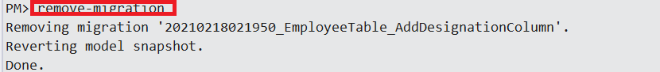

## 6. Generating SQL Script

This command is used to generate the SQL script for the database

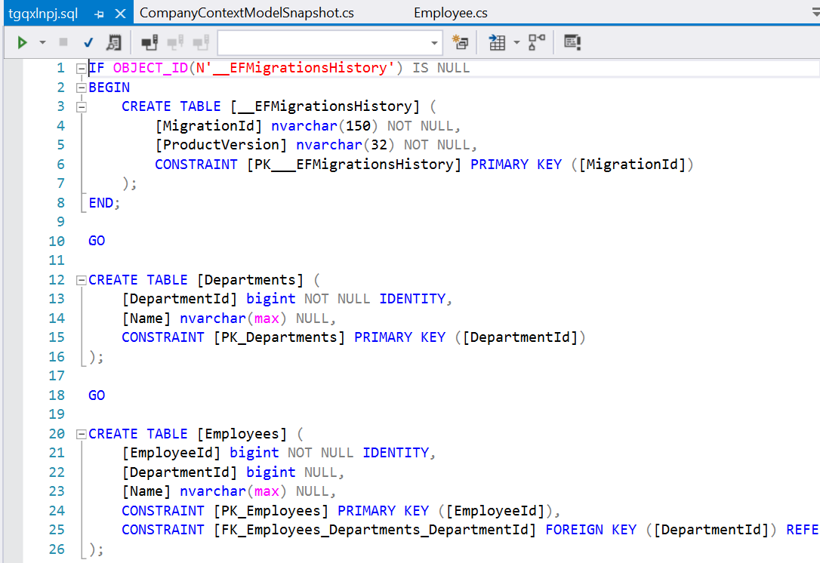

## 7. Scaffold-DbContext

Generates a DbContext and entity type classes for a specified database.



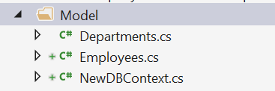

## 8. Get-DbContext

Gets information about a DbContext type.

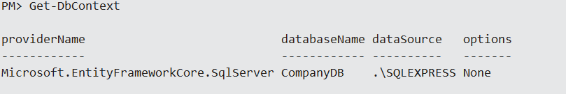

## 9.Drop-Database

